3(a)

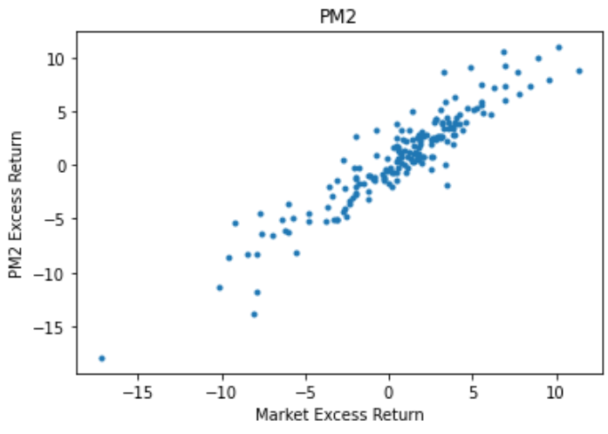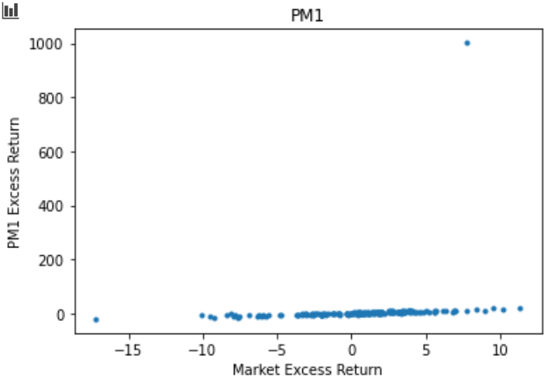

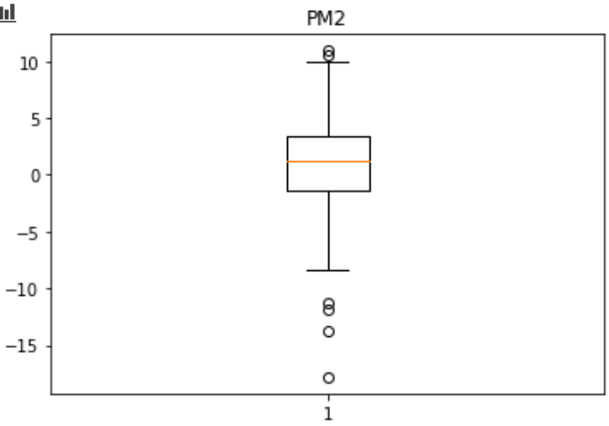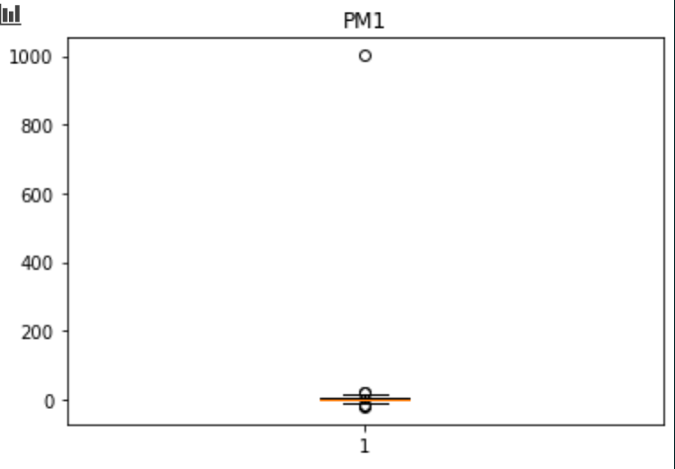

As the boxplot shows, PM1 has a significant outlier which has 1000% return for a single month. Compared with her returns on other months, we believe that this is due to data error and I will set the portfolio return of this month equaling to the market return.

Statistic for two PMs:

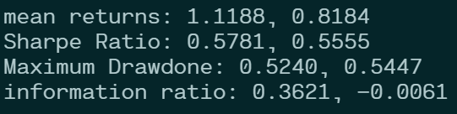

2. 3-factor model regression result for two PMs:

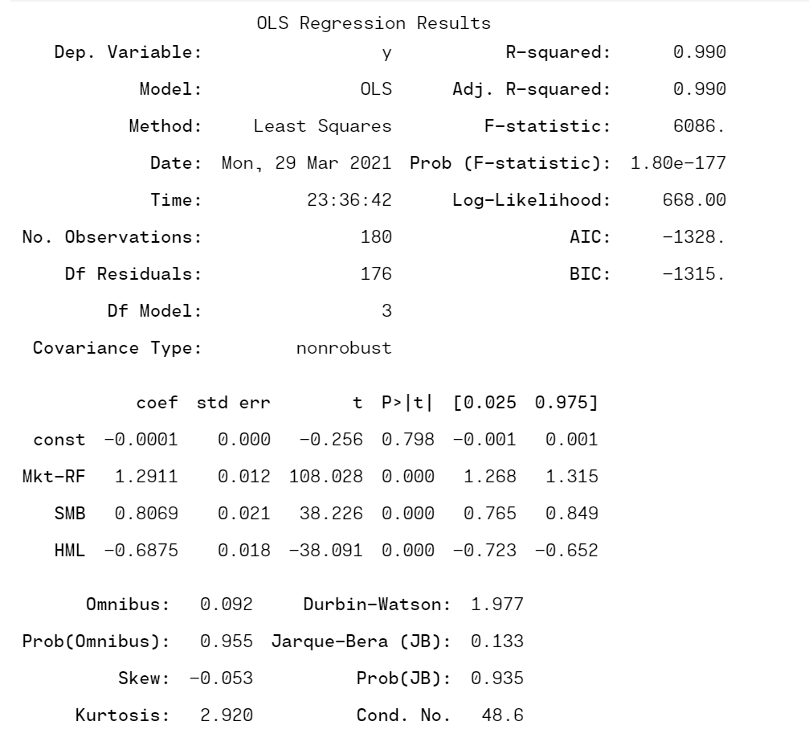

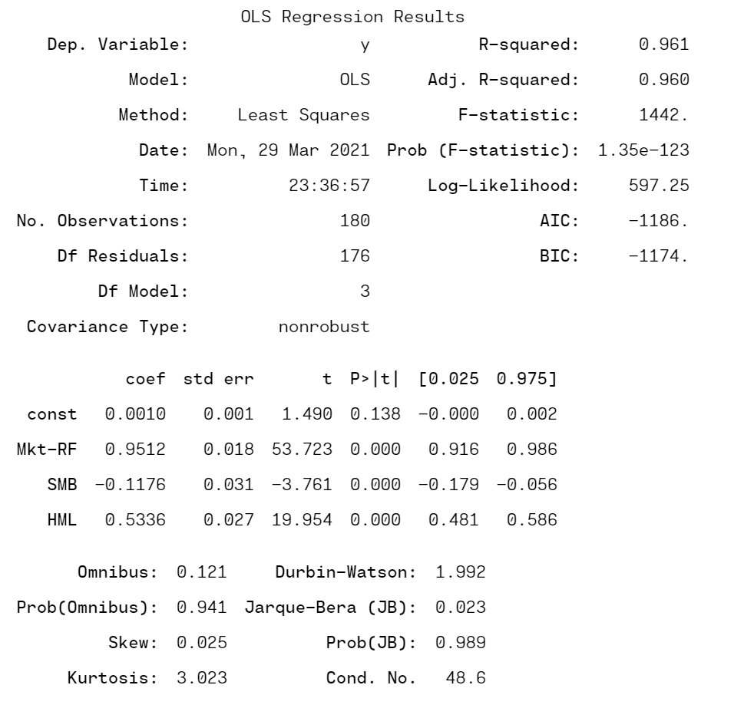

The evidence for both PMs to beat the market based on 3-factor model is insignificant.

3(c)

Task 1: which PM is better at beating the market? For this question we construct a portfolio that longs PM1 and short PM2, and check if the alpha is significantly positive or negative.

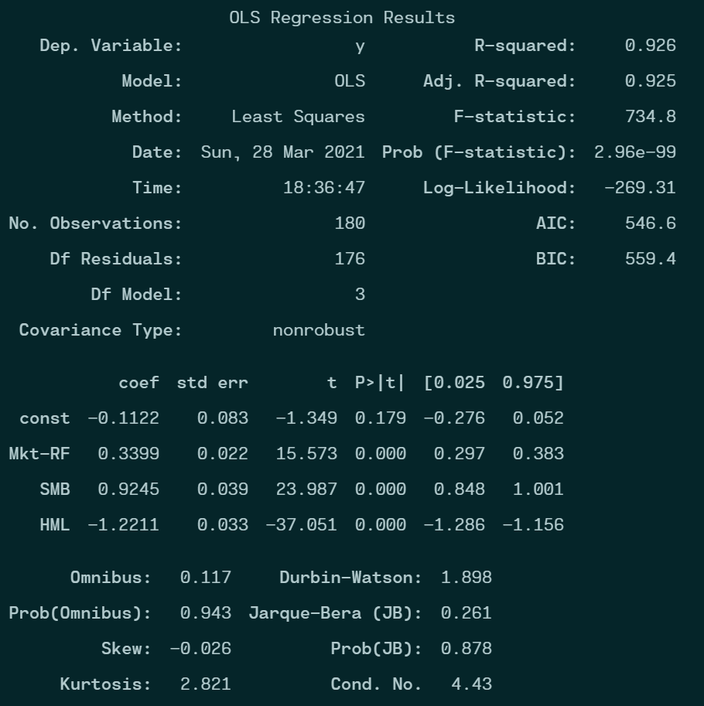

There is no strong evidence that the alpha of the portfolio is nonzero. Thus, we cannot judge with statistical confidence that one PM is better than the other.

Task 2: Which can generate a higher Sharpe Ratio?

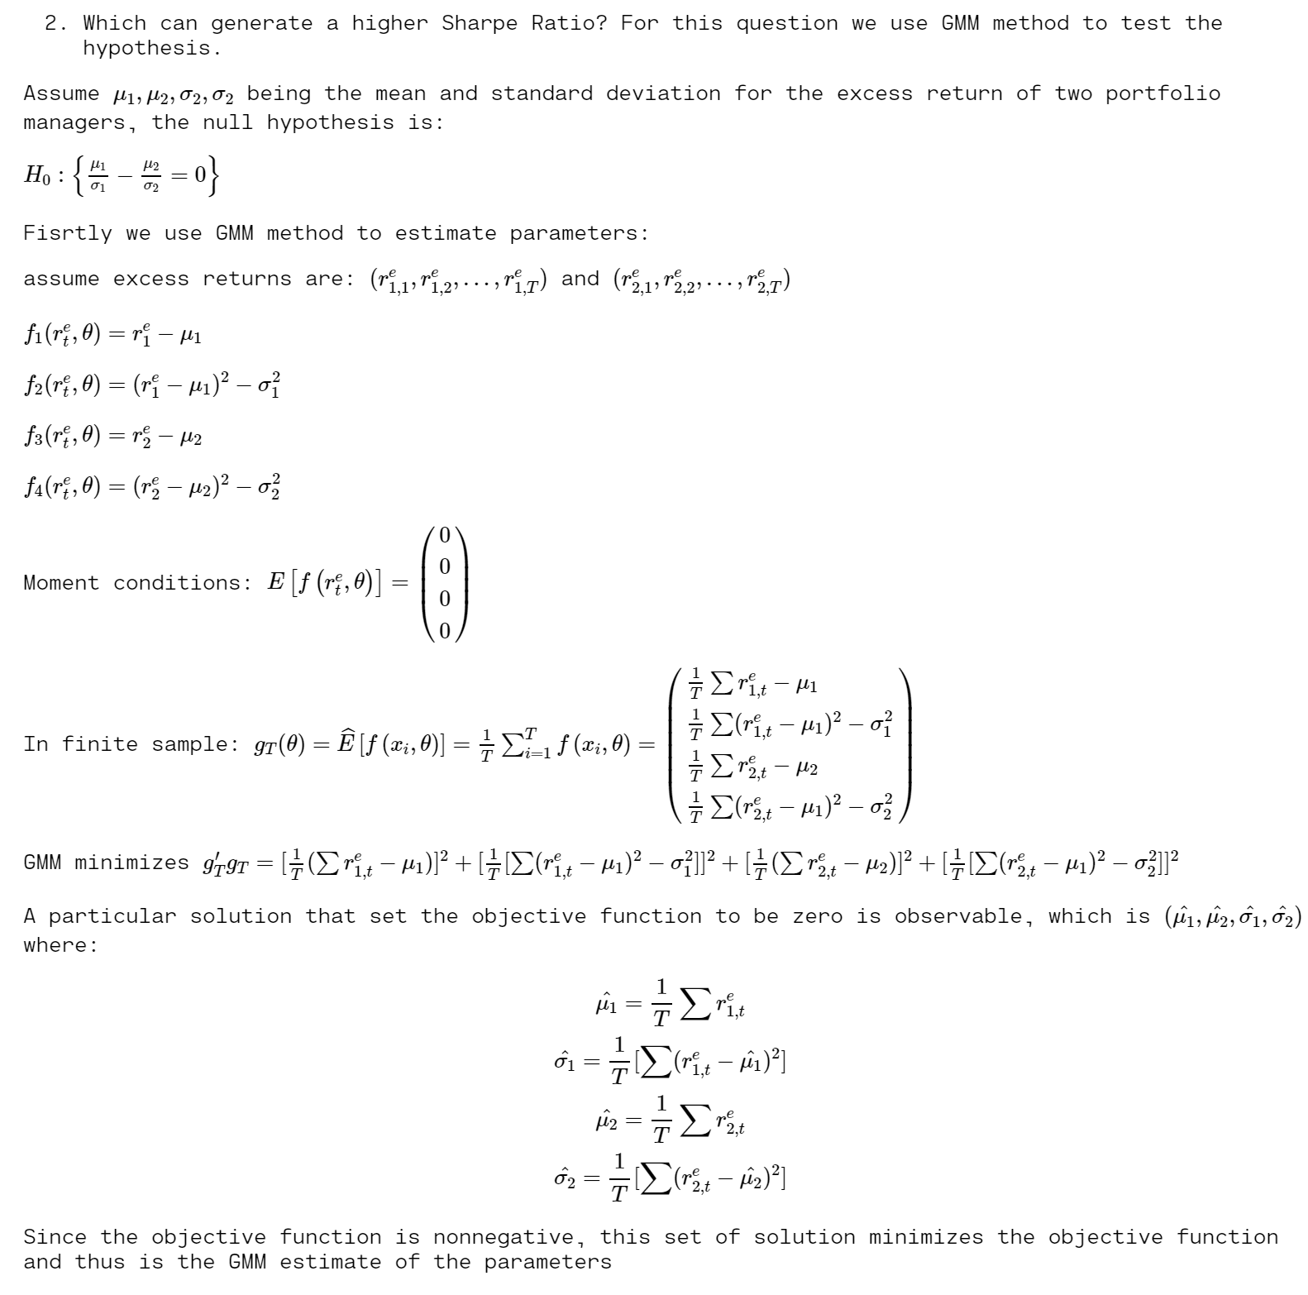

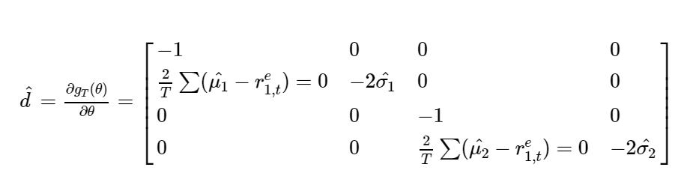

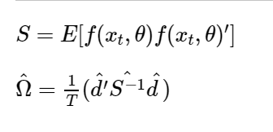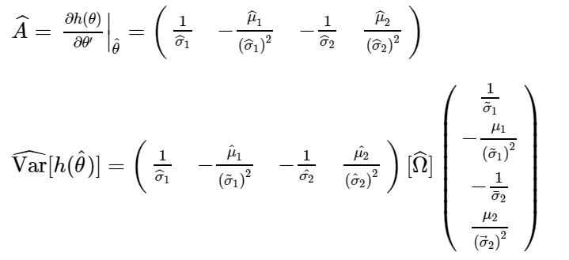

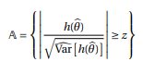

After calculation (see from codes attached), test statistic = 0.118 which is not significant. So we cannot reject the hypothesis that two PMs have the same Sharpe Ratio.

Task 3: which can generate higher information ratio?

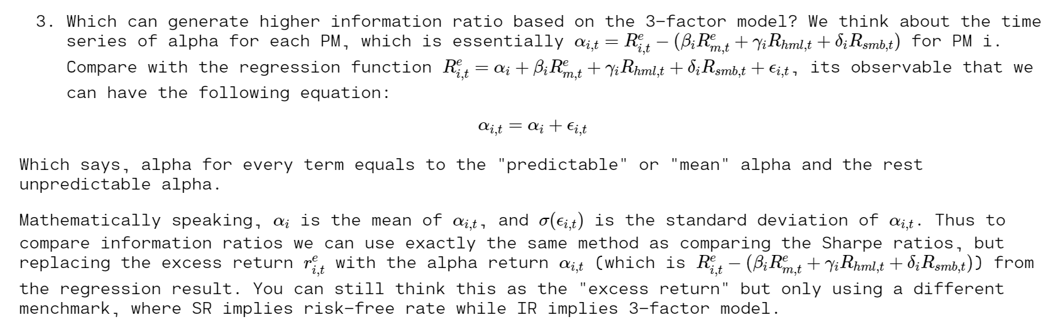

Now A = -0.207, still cannot provide significant evidence to reject the null hypothesis that two PMs have the same information ratio.